Higher Education Working Group on Special Needs

Recommendations for Higher Education Institutions (HEIs)

The Erasmus+ Higher Education Working Group on Special Needs recommends:

- To place the information for Erasmus+ students and staff whose physical, mental or health-related conditions is such that their participation in Erasmus+ would not be possible without extra financial support (from here on referred to as “students and staff with physical, mental or health-related conditions”) prominently on your webpage and other communication channels in an accessible format.

- To designate one person to establish a liaison and cooperation between the International Relations Office and Disability Office(r) at your institution, to promote and support the programme to students and staff with physical, mental or health-related conditions, for example by sharing knowledge and expertise, inviting the Disability Office(r) to Erasmus+ promotion weeks at your institution, etc.

- To include the following optional question in the standard Erasmus+ application form for outgoing students and staff, to invite them to disclose their individual needs: "Do you have access needs (physical, mental or health-related conditions)? Yes/No (optional). If yes, we invite you to disclose this information so that your needs can be addressed and you can apply for an additional grant in order to cover the extra costs which may incur during your Erasmus+ mobility."

- To specify in the Inter-Institutional Agreements what measures your institution is implementing to create an inclusive environment, and what infrastructure and support services it provides to students and staff with physical, mental or health-related conditions; and to use the information from your partner institutions in the Inter-Institutional Agreements to best orient your students and staff to make informed choices about their mobility destination.

- To fill in the information of your institution in MapAbility – an online tool mapping the accessibility of higher education institutions developed by the Erasmus Student Network (ESN) at http://exchangeability.eu/mapability-map

- To keep a close cooperation with your partner institutions at all stages of the mobility on accessibility needs of your Erasmus+ students and staff physical, mental or health-related conditions.

- To have a look at the A-Z Guide to inclusive international mobility and to seek more relevant information on access and diversity in study abroad on the EAIE Access & Diversity platform.

- To promote the added value of a mobility experience towards the employability of graduates to your prospective students, and track your graduates in their future careers.

- To involve former Erasmus+ participants (students and staff) with physical, mental or health-related conditions as Ambassadors for the programme to share their experience with relevant parties and stakeholders.

- To explore the possibility of using Erasmus+ staff mobility for training periods for your administrative staff in IROs, Disability Office(r), etc. to carry out job-shadowing activities in receiving institutions to learn more about the way they work with students and staff with physical, mental or health-related conditions and create synergies.

- To draw from Erasmus+ Organisational Support grant to support promotional activities in this area and/or to organise short preparatory visits to best prepare students and staff with physical, mental or health-related conditions for their upcoming mobility.

- To use the flags for special needs in the MobilityTool+ (the EU reporting tool for Erasmus+) according to the following principles:

- Tick the flag "Participant with Special Needs" in case the student or staff has disclosed the information that they have physical, mental or health-related conditions. The flag should be ticked even if the participant does not receive EU budget (in which case, the "EU Special needs support" field should remain at zero).
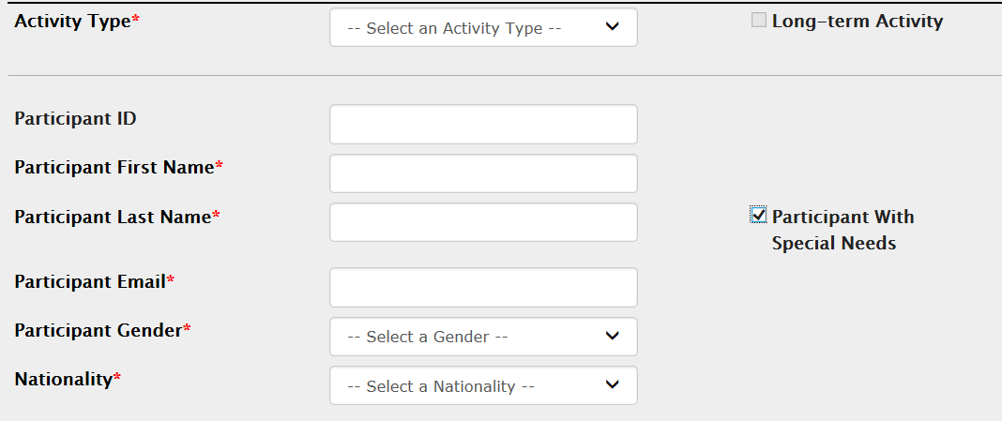

- If the participant doesn't receive the EU Special Needs Support (e.g. because additional budget was not needed to accommodate for their access needs, such as for participants who need more time during exams), write a comment in the EU Special Needs Support section, explaining the access needs of the participant, and leave 0 (zero) as a value.

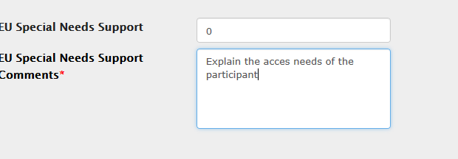

- If the participant receives the EU Special Needs Support, write the amount and explain in the comments the access needs of the participant and for which services this budget is used.
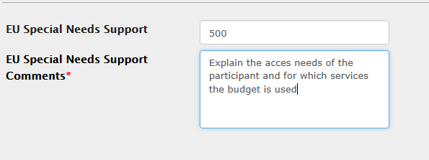
- As outlined in the Erasmus+ Programme Guide, HEIs need to describe on their website how students and staff can request the special needs support. It is recommended to do so by using the common text provided in Error! Reference source not found. of this document on your website to inform your students and staff with physical, mental or health-related conditions about Erasmus+ mobility opportunities and support.

